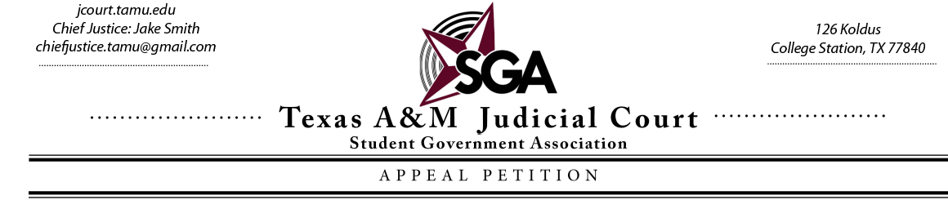
This Appeal may be submitted online via email to the Chief Justice: chiefjustice.tamu@gmail.com.
Please fill out the grey text boxes and check the boxes
Name of Appellant:text. Phone Number:text. Email:text.
If you are someone filling out this form who is not the Appellant, please provide your name as well as your contact information.
Name:text. Phone Number:text. Email: text.
Please list the organization and/or person that you are filing this case against.
Name:next. Phone Number:erxt. Email:text.
Every student may request a Judicial Advocate at any point. Judicial Advocates are responsible for assisting those who ask for counsel for their hearings in front of the Judicial Court. If asked, the Judicial Advocate will support their assigned party to prepare the best case possible.
As of now, would you like a Judicial Advocate to be assigned to you? Yes ☐ No ☐
To get a better idea of the case at hand, please answer the following inquiries to the best of your abilities. If you need to do so, you may attach extra pages in your email submission of this form. Although there is no minimum or maximum limit to the number of pages that you may submit, brevity is key. If available, please attach copies of any documents that you deem relevant, prudent, and that would help the Court determine whether or not to accept the case.
Facts State the facts that are pertinent to your appeal. What occurred that prompted you to seek redress from the Court? Specificity is key. Give details on who, what, when, where, why, and how.
text.
Constitutional/Statutory Citations Please tell the Court specifically what passages, if any, in the Student Government Constitution, by-laws, or Senate legislation, have been violated. In addition, if any of the aforementioned documents bolster your case in any way, please list those passages as well.
text.
Special Circumstances (If Applicable) Are there any special considerations that the Court should take into account? Does this case need to be heard in a specific time frame? Should the Court act by writing an injunction? Please explain.
text.
Relief That You Are Seeking What would you like the Court to do to rectify the harm that you have faced in your appeal?
text.
Certification Statement, Rights, & Signature
I hereby certify to the best of my knowledge, that all statements and documents contained herein and attached are true, and correct. I acknowledge that the submission of false documents and/or statements is a violation of the Aggie Honor Code.
- I understand that if I have not received a decision within five (5) working days, it is my responsibility to check with the Judicial Court
- I understand that I will receive the decision on this appeal by means of the contact information I provided in this form. If I wish to get a signed copy, I must contact the Judicial Court.
- I understand that by submitting this electronically, that constitutes an electronic signature on behalf of the person who submitted it.

Signature: text. Date: text.

If you have any inquiries, please contact Chief Justice Jake Smith: chiefjustice.tamu@gmail.com

